L2 or L3 or tests name: AU-121-05-CSDR Identity and Access Management (IAM)
Legal entities in scope: DBAG/CBL/ECAG/CBF/CH/LuxCSD/CS/CI/CFCL/ExR/EFAG

[From RCA – Hint: IA Heads highlighted a point for consideration: As mentioned in the BCA, please ensure that during the framework (FW) review, steer clear of re-evaluating any aspects that have already been covered in the validation work. Additionally, if there are ongoing framework or process changes prompted by regulatory findings, IA to avoid duplicating those efforts.]

Reference: DORA Chapters – 2(Arts: 6, 9) – supported by RTS – RMF: Chapter 2 (II), RTS Articles: 19, 20, 21
Take it into account the DORA relevant requirements and compliance

(TP1) Regarding these L2 (IAM Governance and PAM Governance), IA to inspect the published “IAM Procedures, V1.0” and “PAM Procedures, V1.0” by 1LoD Group Security in June/July 2025. Assess for alignment to 2LoD IAM Guidelines v1.0 (published in January 2025) on the DORA requirements, roles and responsibilities, detailed guidance against procedures, etc., - necessary clarity into the Frameworks / Written rules must be examined on a sample-basis and adequacy challenged.

Procedures / Criteria / documents used:
- Identity and Access Management Procedure - TP1_Evidence 1. Identity and Access Management Procedure.pdf
- Privileged Access Management Procedure - TP1_Evidence 2. Privileged Access Management Procedure.pdf
- Identity and Access Management Guideline - TP1_Evidence 3. Identity and Access Management Guideline.pdf
- ICT Risk Management Policy - TP1_Evidence 4. ICT Risk Management Policy v2.0.pdf
- Human-related ICT Management Guideline - TP1_Evidence 5. Human-related ICT Management Guideline.pdf
- Data Centre and Physical Protection Guideline - TP1_Evidence 6. Data Centre and Physical Protection Guideline.pdf
Testing:
IA performed below as part of the testing:
- Inspected the published “IAM Procedures, V1.0” and “PAM Procedures, V1.0” by 1LoD Group Security in June/July 2025.
- Assessed for alignment to 2LoD IAM Guidelines v1.0 (published in June 2025, latest version) on the DORA requirements, roles and responsibilities, detailed guidance against procedures, etc.,
- Examined whether there is necessary clarity into the Frameworks/Written rules and adequacy reviewed and challenged.

Outcome:
Based on the testing performed (listed above), IA concluded that the procedures and guidelines on the DORA requirements, roles and responsibilities were aligned and detailed guidance was included. Please refer to the testing results documented in the Workpaper sheet (Test Step 1_Procedure vs Guidelines_Testing Results.xlsx), including references to the applicable evidence.

TP1 Conclusion
No observations noted.

(TP2) IA to validate the service availability and service resiliency around the concentration risk for critical applications - Azure AD / Entra ID and CyberArk. Are alternative provisions in place to carry out critical tasks such break-glass emergency access, and do these circumventions trigger SIEM alerts?

[From RCA - Hint: How would DBG survive without these being available for an extended period? How do we ensure that critical tasks have a plan-B / break-glass emergency access, and do these circumventions trigger SIEM alerts?]

Procedures / Criteria / documents used:
- Meeting with Group Security team - TP2_Evidence 1_2025-067 IAM and PAM walkthrough.msg
- Privileged Access Management Procedure - TP2_Evidence 2. Privileged Access Management Procedure.pdf
- Emergency Account Management Guide - TP2_Evidence 3. Emergency_Account_Management_Guide_V1.1.pdf
- Responses from Azure/Entra ID Application Owner - TP2_Evidence 4. 2025-067 IAM and PAM Audit - Azure_Entra ID_Responses.msg
- Responses from CyberArk Application Owner - TP2_Evidence 5. 2025-067 IAM and PAM Audit - CyberArk_Responses.msg
- IT DR Test 2024 Report, including Azure/Entra ID - TP2_Evidence 6. IT DR Test 2024 Report_Azure_EntraID.pdf
- IT DR Test 2024 Report, including CyberArk - TP2_Evidence 7. IT DR Test 2024 Report_CyberArk.pdf
Testing:
Meetings held and Documents Reviewed:
IA performed below as part of the testing:
- Held meetings with the team below from IAM and PAM team on 9th October 2025:
  - Carsten Kreuz (Vice President | Head of Identity & Access Management
  - Florian Laudensack (Senior Associate Vice President | Identity and Access Specialist)
  - Stephan Hampel (Vice President | Identity and Access Specialist)
  - Aamir Maliyakal (Senior Associate | Identity and Access Specialist)
- Based on the meetings held and documents obtained, IA noted that:
  - If Azure AD/Entra ID and CyberArk are down/unavailable, emergency access processes are initiated.
  - The onboarded application owners are responsible for their emergency processes.
  - Sections 4.2.3.1 and 4.2.3.2 of the PAM procedure (extracted below) includes details on the usage of Emergency and Break Glass accounts
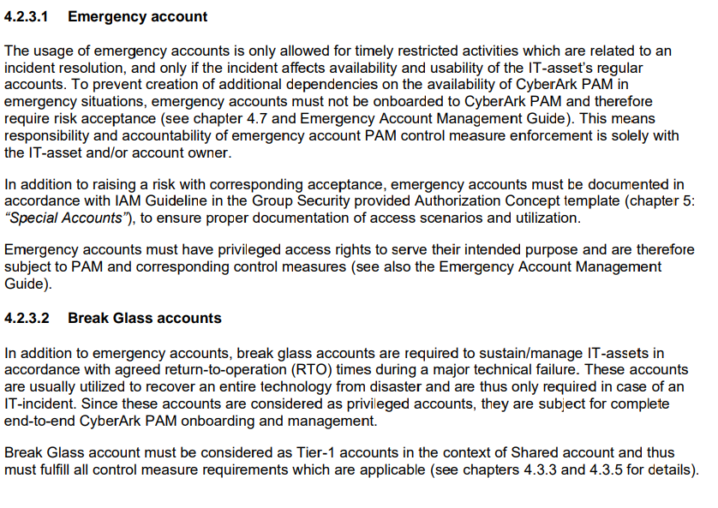
  - Section 3.2 of the PAM procedure lists the Responsible, Accountable, Consulted and Informed (RACI) matrix of the various stakeholders involved during emergency situations. IA noted below key points:
    - All privileged accounts must be inventoried in a privileged account inventory – page 16
    - Logging and Monitoring: Logs must be made available for Security Information and Event Management (SIEM) in a structured way to allow the detection of unauthorized privileged accesses – page 17
    - Threat Analytics SIEM / PAM: Session monitoring solution must allow for data analysis / logging of actions made by privileged access – page 18
    - In emergency situations, the initial and mutual approval for privileged access must occur through the responsible Manager on Duty. The Ticket Owner must ensure that the incident documentation including approval is provided within 24 hours – page 18

- As referenced in section 4.2.3.1 of PAM Guidance, IA reviewed the “Emergency Account Management Guide” and noted that page # 9 documents the below key requirements:
  - Emergency accounts must be flagged and documented as such in the IT-assets’ (digital) authorization concept.
  - Emergency accounts must be reported to Privilege Account Inventory (PAI)
  - SIEM alerts must be created for emergency account utilization (via Business JIRA) to ensure proper usage awareness and documentation purposes.

Validation of Service availability and resiliency:

- IA communicated with the Application Owners of Azure AD/Entra ID and CyberArk i.e. Jakub Stedry (Director, Solution Architect) and Pascal Venier (Vice President, Head of Security IT Engineering Run and Maintain) respectively, obtained the supporting evidence on service availability and resiliency, and noted that Disaster Recovery (DR) tests are conducted once a year to test the service availability and resiliency.
- IA team obtained the last DR test reports for both Azure AD/Entra ID and noted that:
  - Azure AD/Entra ID was tested as part of the Corporate IT DR test performed on 27th July 2024 with the below scope:
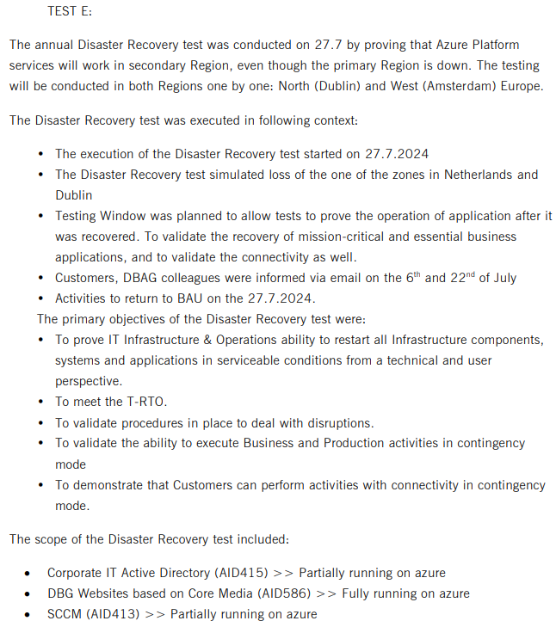
  - Accordingly, the tests performed and the test results were successful – as documented on page # 26 of the IT DR Test report.

- IA team obtained the last DR test reports for both CyberArk and noted that:
  - CyberArk was tested as part of the IT DR test performed on 12th October 2024 with the below scope:
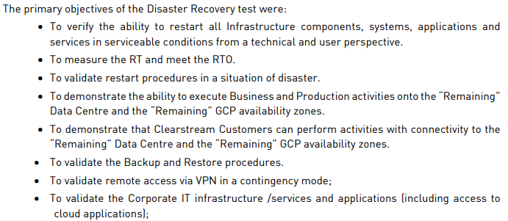
  - Accordingly, the tests performed and the test results were successful – as documented on page # 14 of the IT DR Test report.

Outcome:
Based on the testing performed (listed above), IA concluded that:
- The service availability and service resiliency around the concentration risk for critical applications - Azure AD / Entra ID and CyberArk is mitigated, which was recently tested in the last IT DR tests.
- Alternate provisions in place to carry out critical tasks such break-glass emergency access, and those circumventions trigger SIEM alerts.
- Group Security team further confirmed that the inadequate maintenance of all emergency accounts in Privilege Account Inventory was a finding raised earlier by the regulator, which is being remediated as part of AMELI project. Please refer to TP3 testing results and documentation.

TP2 Conclusion
No observations noted.

(TP3)
FuN: 241202154134 - Management of Emergency Accounts
- When establishing a new IT asset that includes privileged accounts, there is a lack of clear guidance regarding the management of emergency accounts. What specific criteria should be used to create an emergency account? If CyberArk is not the designated storage location, where should these accounts be maintained? Additionally, how can we ensure that emergency accounts remain accessible to IT asset owners and their designated deputies during an emergency situation?
- At present, there is no designated individual in the first line of support addressing these concerns. Carsten Kreuz currently only provides onboarding status updates to the DSC, without taking further action.
- Different topic: it might be beneficial to discuss with Carsten the feasibility of utilizing a Crawler to identify privileged accounts across storage, network devices, servers, and databases, thereby reducing our dependence on IT-asset owners.

Procedures / Criteria / documents used:
- Emergency Account Management Guide - TP3_Evidence 1. Emergency_Account_Management_Guide_V1.1.pdf
- AMELI Project findings - TP3_Evidence 2. AMELI Overview - IA_As of 3rd Nov 2025.xlsx
Testing:
Meetings held and Documents Reviewed:
IA performed below as part of the testing:
- Held meetings with the team below from Group Security (IAM and PAM) team on 9th October 2025:
  - Carsten Kreuz (Vice President | Head of Identity & Access Management
  - Florian Laudensack (Senior Associate Vice President | Identity and Access Specialist)
  - Stephan Hampel (Vice President | Identity and Access Specialist)
  - Aamir Maliyakal (Senior Associate | Identity and Access Specialist)
- Based on the meetings held with Group Security team and documents obtained, IA noted that:
  - There is an approved “Emergency Account Management Guide” last reviewed in June 2025 (TP3_Evidence 1. Emergency_Account_Management_Guide_V1.1.pdf), which provides an overview of the emergency account lifecycle including creation, handling, management and documentation.
  - Section 2.1, 2.2 and 2.4 of the guide documents on the emergency account utilization, functional set up , and compliance requirements (extracted below), which provide adequate guidance regarding the management of emergency accounts, criteria to be used to create an emergency account, where should these accounts be maintained. Additionally, how emergency accounts remain accessible to IT asset owners and their designated deputies during an emergency situation:
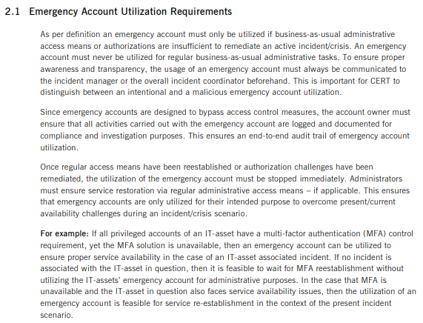
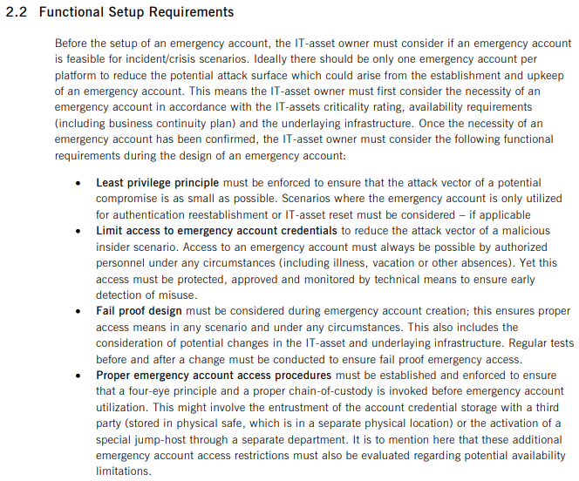

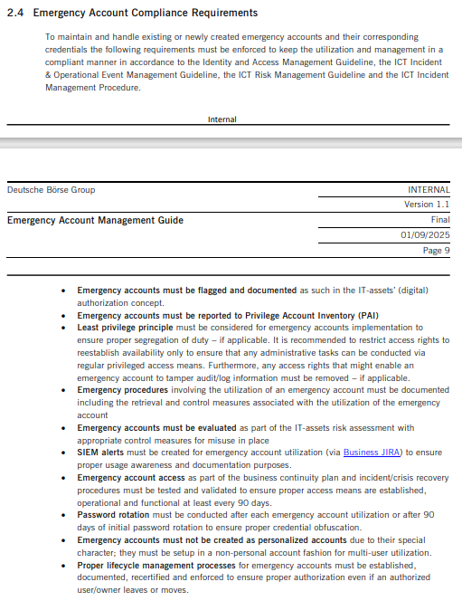
- IA further noted that the PAM SharePoint link (Privileged Access Management PAM) provides further guidance on the point of contact for all PAM related queries, including emergency accounts.
- During the meeting held with Group Security team on 9th October 2025 (documented above), IA team queried on the feasibility of utilizing a Crawler to identify privileged accounts across storage, network devices, servers, and databases, thereby reducing our dependence on IT-asset owners. However, it was confirmed that there no such plans due to the complexity of the technology environment, and cost benefit of using Crawlers.
- Group Security team also confirmed that the weaknesses in the usage of emergency accounts was raised by the regulator, which are being remediated as part of the ongoing AMELI project. Hence, IA obtained the report of all findings that are being remediated and confirmed that Finding ID # 274o, includes deficiencies related to emergency accounts, and are being remediated – refer to report for details (TP3_Evidence 2. AMELI Overview - IA_As of 3rd Nov 2025.xlsx).

Outcome:
Based on the testing performed (listed above), IA concluded that:
- There is clear guidance regarding the management of emergency accounts, including specific criteria to be used to create an emergency account.
- If CyberArk is not the designated storage location, the emergency accounts should be stored in PAI.
- Emergency accounts remain accessible to IT asset owners and their designated deputies during an emergency situation are documented in the authorization concepts and onboarded to PAI.

TP3 Conclusion
No observations noted.

(TP4) IA to inspect and validate the following areas of risk identified by ECAG CRIT Information Security Office (RIT) - KRITIS Office email
- Inconsistent Legal Entity specific reports regarding privileged access onboarding to monitoring tools
- Onboarding to CyberArk i.e. tracking and monitoring measures implemented when privileged access is onboarded
- KPI breach reporting for PAM onboarding to Group Security

Procedures / Criteria / documents used:
- TP4 Evidence 1. AMELI Overview - IA_PAM Onboarding Finding Details.xlsx
- TP4 Evidence 2. KPI PAM Breach analysis.xlsx
- TP4 Evidence 3. SUPR-2526 Details.pdf
- TP4 Evidence 4. PAM_Coverage_Report_20250901.xlsx
- TP4 Evidence 5. Service_KPI_SDS_2025_ECAG_2025-09-02.xlsx
- TP4 Evidence 6. APMS Onboarding Procedure Guideline.pdf
- TP4 Evidence 7. APMS - Mandatory Attributes - v.2.9.pdf
- TP4 Evidence 8. DBG_PAM_FAQ_v1.0.pdf
- TP4 Evidence 9. 202505_DSC_KPI.pdf
- TP4 Evidence 10. 202506_DSC_KPI.pdf
- TP4 Evidence 11. 202508_DSC KPI.pdf

Testing:
Meetings held and Documents Reviewed:
IA performed below as part of the testing:
- Held meetings with the team below from Group Security (IAM and PAM) team on 9th October 2025:
  - Carsten Kreuz (Vice President | Head of Identity & Access Management
  - Florian Laudensack (Senior Associate Vice President | Identity and Access Specialist)
  - Stephan Hampel (Vice President | Identity and Access Specialist)
  - Aamir Maliyakal (Senior Associate | Identity and Access Specialist)
- Group Security team confirmed that there are remediation actions in progress by the team, on various areas related to PAM onboarding as part of AMELI project, which are being independently validated by IA.
- Accordingly, IA obtained the list of all remediation actions/packages (1. AMELI Overview - IA_PAM Onboarding Finding Details.xlsx) and independently reviewed and confirmed that Finding IDs # 274o, LAM_02, and LAM_05, include specific remediations in progress.
However, IA team reviewed the individual areas highlighted by ECAG CRIT Information Security Office (RIT) - KRITIS Office and the actions being taken or progress made, and independently validated them:
1. Inconsistent Legal Entity specific reports regarding privileged access onboarding to monitoring tools:
A. Reports regarding onboarding privileged accounts to PAM monitoring tools:
- It was highlighted to IA team that the Compliance report and Information Security Performance Indicator Reporting (ISPIRI) KPIs are not aligned or consistent with each other. KRITIS team performed an analysis on the differences noted for the months January to May 2025 (2. KPI PAM Breach analysis.xlsx) and raised a change ticket to track the progress on the actions being taken ([SUPR-2526] PAM KPI and report improvement - Vulnerability Management Tool & Risk Register) or TP4 Evidence 3. SUPR-2526 Details.pdf.
- IA independently obtained the Compliance Report (Refer to tab “Using Legal Entities” and section “ECAG” in TP4 Evidence 4. PAM_Coverage_Report_20250901.xlsx) and ISPIRI report (Refer to tab “PAMs” in TP4 Evidence 5. Service_KPI_SDS_2025_ECAG_2025-09-02.xlsx) for the month of September 202.
- Based on the review of the above reports, IA noted that, for ECAG the total assets in scope were 6415 and 6445 in the Compliance report and ISPIRI report respectively, due to the remediation activities in progress.
B. Reports regarding onboarding privileged accounts to PAM monitoring tools:
- It was highlighted to IA team that the definition of “Onboarded to IIQ Description” in APMS is unclear, which could lead to incorrect understanding between the stakeholders using the APMS data and inaccurate reporting.
- IA obtained the APMS Onboarding Procedure Guideline (TP4 Evidence 6. APMS Onboarding Procedure Guideline.pdf) and APMS Mandatory Attributes document (TP4 Evidence 7. APMS - Mandatory Attributes - v.2.9.pdf) and noted that definition of “onboarded” was not documented in them or any other applicable documents.
- During the discussions held with the Group Security team (listed above), the IA noted that below are the descriptions of the “Onboarded to IIQ Description”, which are not yet officially documented but are defined for IIQ development JIRA tickets, as a requirement:
0 = Technical Onboarded
1 = Automatically Onboarded
2 = Automatically Onboarded with Recon
3 = Manually Onboarded
4 = Manually Onboarded with Recon
5 = Semi Onboarded
6 = Semi Onboarded with Recon
R = in Review
P = Onboarding in Progress
O = Out of Scope
U = Unknown Status
D = Decommissioned
- Group Security team agreed that the above has to be adequately documented in an approved document and accepted the gap.
2. Onboarding to CyberArk i.e. tracking and monitoring measures implemented when privileged access is onboarded:
- It was highlighted to IA team that there is no ticket system to manage the onboarding and tracking or which monitoring measures have been implemented when privileged access is onboarded.
- Based on the discussions held with Group Security (listed above) and PAM FAQ (as of June 2025) obtained (TP4 Evidence 8. DBG_PAM_FAQ_v1.0.pdf), IA noted that the Group Security and the company utilizes JIRA tool as a ticketing system for tracking and monitoring related to CyberArk onboarding, which was documented in the several sections of the document, and specifically in section 2.9 and 2.11.
3. KPI breach reporting for PAM onboarding to Group Security:
- It was highlighted to IA team that there were consecutive KPI breaches (related to PAM onboarding) for Q2 2025, which was reported to applicable committee.
- Hence, IA obtained the Digital Security Committee (DSC) decks presented for the last three months i.e. May, June and August 2025 (due to holidays, July DSC was not held) – refer to TP4 Evidence 9. 202505_DSC_KPI.pdf, TP4 Evidence 10. 202506_DSC_KPI.pdf, and TP4 Evidence 11. 202508_DSC KPI.pdf.
  - For May and Jun 2025 - IA noted that the slide # 73 to 80 listed the KPIs on PAM onboarding, including breaches
  - For Aug 2025 - IA noted that the slide # 78 to 85 listed the KPIs on PAM onboarding, including breaches
- IA queried Group Security team on the actions being taken to improve the KPI breaches noted above. Group Security team confirmed that they are actively working to improve the KPIs by actively working with the asset owners to onboard them in PAI, which are also part of remediation actions being taken in AMELI Finding IDs # 274o, LAM_02, and LAM_05 (documented above).

TP4 Conclusion
IA concluded that the definition of “Onboarded to IIQ Description” in APMS is unclear, which was accepted by Group Security team. Please refer to the relevant finding for further details.

SPRINT 3:
(TP5) FuN 241121131418 - Status of relevant SDSs

Part of the BCA of the 2024-078 Privileged Access Management audit is the section "Data from Outsourcing" It lists the following contracts for Identity & Access Management (S):

S4 ID | Supplier Name | Service description short incl. processing task | Outsourcing Pre-Assessment result
1319395 | Constructive Consulting GmbH | Constructive will support in: Onboarding applications to Identity and Access Management platform (Sailpoint IIQ). Service in this area will be performed by CC-IAM Team | Other 3rd Party Service
1320240 | Devoteam GmbH | Assessment/Upgrade plan for new version(s) of ForgeRock AM, New application onboarding, Extend the capabilities to support multiple backend system, introduce new Authentication options, support additional account types via Trees/Chains, Customize scripts, Customize UI, Hardening the environment, Update/Upgrade/Maintenance of AM, Maintenance activities: AM platform | Other 3rd Party Service
1318370 | Identity-Team GmbH | Assessment/Upgrade plan for new version(s) of ForgeRock AM, New application onboarding, Extend the capabilities to support multiple backend system, introduce new Authentication options, support additional account types via Trees/Chains, Customize scripts, Customize UI, Hardening the environment, Update/Upgrade/Maintenance of AM, Maintenance activities: AM platform | Other 3rd Party Service
1319018 | Kogit GmbH | KOGIT continues to support the implementation of measures in Identity and Access Management System based on SailPoint IdentityIQ and Nexis Reporting Tool for the efficient connection of further applications (by advising and configuring the system + the second level support on technical issues as well as change and release management | Other 3rd Party Service
1319559 | SailPoint Technologies, Inc. | SailPoint IIQ support | not Regulatory Relevant Outsourcing

As part of the yearly reviews and requirements from the Ameli and Dora projects, changes in these SDSs are in preparation. Final versions are expected in December 2024. The current status of these SDS should be checked and if audit activities result from the updates. In case Ameli and Dora projects are not sufficiently progressed, then the contracts can be checked in one of the next IAM audits.

Testing:
Based on the meetings held within the Internal Audit team and due to the severe weaknesses identified during the recently released IA report “2025-033 Outsourcing and Contract Management & 2025-026 Risk Focus Audit Vendor Risk Management” (TP5_Evidence 1.2025-033 & 2025-026 Audit Report.pdf), it was agreed to keep this Future Note Open and revisited once the remediation actions on the findings noted (in above audit) are completed by management.

TP3 Conclusion
Not Applicable.

SPRINT 3:
(TP6) Follow up on FuN 250801082944 Control over number of members in role owner workgroups

Procedures / Criteria / documents used:
- TP6 Evidence 1. DBG_IAM_End_User_Training.pdf
- TP6 Evidence 2. 2025-067_ Role without 3 owners.msg
- TP6 Evidence 3. User Access Recertification Process_v1.0.pdf
- TP6 Evidence 4. NPI Access Recertification Process_v1.0.pdf
- TP6 Evidence 5. 2025-067 IAM and PAM __ walkthrough questions II_ CW42.msg
- TP6 Evidence 6. IAM Update RoleEntitlement Owner Workgroups with less than three members.msg
- TP6 Evidence 7. IAM_ Notification about empty owner workgroups_Reports Run on 15th Sep 2025.msg
- TP6 Evidence 8. Workgroup Analysis by IA.xlsx

Testing:
Meetings held and Documents Reviewed:
IA performed below as part of the testing:
- Held meetings with the team below from Group Security (IAM and PAM) team on 9th October 2025:
  - Carsten Kreuz (Vice President | Head of Identity & Access Management
  - Florian Laudensack (Senior Associate Vice President | Identity and Access Specialist)
  - Stephan Hampel (Vice President | Identity and Access Specialist)
  - Aamir Maliyakal (Senior Associate | Identity and Access Specialist)

- Based on the meetings held with Group Security team and documents obtained, IA noted that:
  - As per the requirements on page # 27 of the IIQ End User Manual (link) - “It is mandatory to have at least 3 members in every workgroup including the Owner of the workgroup.”
  - As per the Future Note details (link), IA independently obtained the screenshots from IIQ and confirmed that the workgroup mentioned in the future note is a role and not a workgroup. The actual workgroup name is “MCP – Production – CFCL - Role Owner”. Refer to the screenshots below:

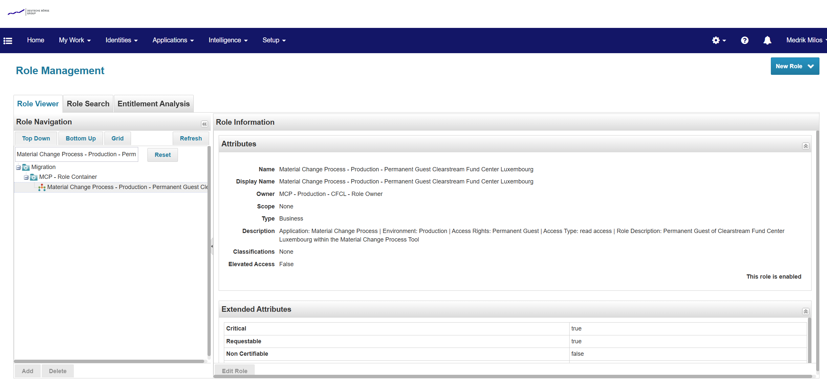

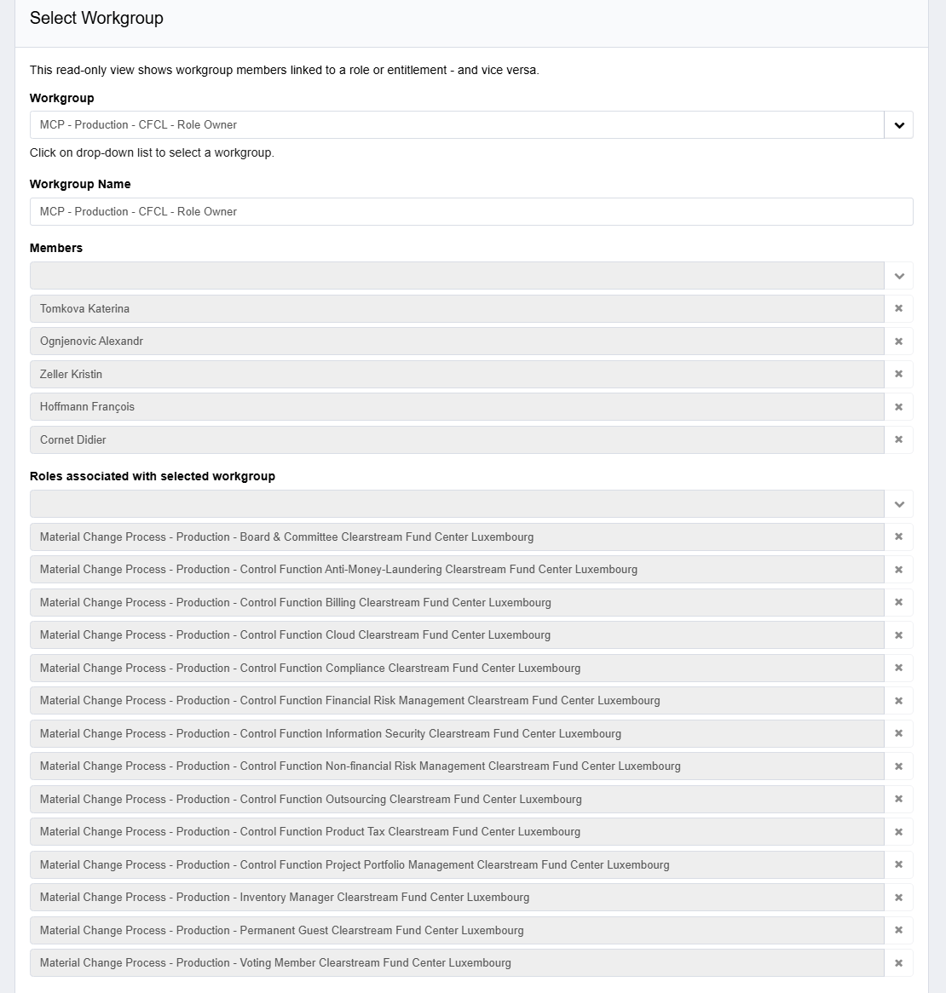

- IA confirmed that Group Security has User Access Recertification Process (link) and Non Personal Identities (NPI) Access Recertification Process (link). The process refers to the review of all user accounts and access authorizations granting access to DBG information and review of privileged access assigned to accounts of non-personal identities, on a semi-annual basis.
- IA obtained the most recent script results ran by Group Security in IIQ, on 15th September 2025 (link) and noted that the workgroups with less than 3 members receive an autogenerated email from IIQ for actions to be taken by the Workgroup owners (link).
- It was further noted that the workgroups with no owners and no roles assigned to the workgroups are deleted by Group Security (link). However, the list of such work groups were not assessed and required actions taken.
- IA independently obtained the list of workgroups with less than 3 members (and zero owners) and performed an analysis and noted the below summarized results. Refer to the complete details in this sheet (link) and applicable finding in the report.

Workgroup Membership Analysis - Summary
Category | Number of Workgroups | Total Members | % for Workgroups
Details of All Workgroups | 23328 | 66051 | -
Less than 3 members assigned to Workgroups | 8214 | 13033 | 35%
0 members assigned to Workgroups | 977 | 0 | 4%
Only 1 member assigned to Workgroups | 1441 | 1441 | 6%
Only 2 members assigned to Workgroups | 5796 | 11592 | 25%
Workgroups assigned to inactive employees | 209 | 55 | -
Staff who left the company having access to Workgroups | 13 | 3 | -

TP6 Conclusion
IA noted that the workgroup members with less than 3 members are not adequately monitored and required actions taken by Group Security. Refer to applicable finding for more details.

